­

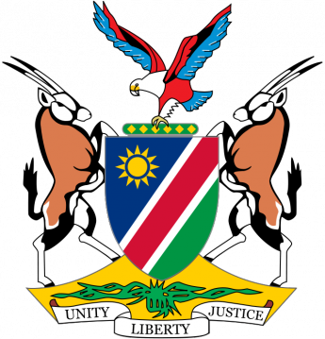

    ­

**DEASA COUNTRY REPORT – NAMIBIA**

**DEASA AFFILIATED INSTITUTIONS:**

* Namibian College of Open Learning (NAMCOL); Mr. H.V. Murangi
* UNAM Centre for External Studies: Dr. N. Mbukusa
* PoN: Centre for Open and Lifelong Learning; Dr D. Mowes
* International University of Management: Prof Fred Opali
* Namibian Open Learning Network Trust (NOLNet): Ms. H. Amadhila

Table of Contents

1. Introduction 1
2. DEASA Key Performance Areas 2
   1. Research Activities3
   2. Capacity Building4
   3. Partnership and Collaboration5
   4. Policy Development and Facilitation6
   5. Quality Promotion7
3. New Innovations 8
4. Challenges9
5. Conclusion10